Today’s Service
May 6, 2018
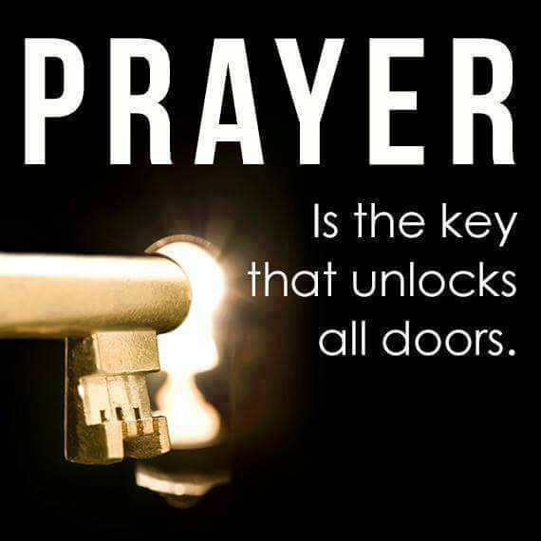
- Call to Worship
- Hymn
- Announcements
- Prayer Requests
- Music
- Sermon
- Offering
- Communion

From the Pastor

There are many misconceptions about the identity of the Holy Spirit. Some view the Holy Spirit as a mystical force; others as the impersonal power that God makes available to followers of Christ. We can know that the Holy Spirit is indeed a divine person because He possesses a mind, emotions, and a will. The Holy Spirit thinks and knows (1 Cor. 2:10). The Holy Spirit can be grieved (Eph. 4:30). The Spirit intercedes for us (Rom. 8:26-27). He makes decisions according to His will (1 Cor. 12:7-11). The Holy Spirit is God, the third Person of the Trinity. As God, the Holy Spirit can truly function as the Comforter and Counselor that Jesus promised He would be (Jn. 14:16, 26, 15:26).
Pastor Tony
Church Information
Last Week’s giving: $ 1,255 Month to date: $ 7,158
Weekly Target: $ 875 Previous month: $ 3,139
Year to Date: $ 13,130 Monthly Target: $ 3,500
YTD target: $14,875 (-1,745) Building Fund: $ 10,580
Adult Sunday School 9:45 am………………………………….. Linda Fraley
Elders
Tony Raker (Pastor)..…………………........... tonyraker@yahoo.com
Delmas (Moe) Ritenour ……………………….. moemar@shentel.net
Finance: Anthony Sinecoff……………………….. sinecoff@gmail.com
Linda Fraley …………………………….. lindaf12@shentel.net

Media: Rob Moses, Scott Tucker, & Tammy Copeland
Bulletin: Rob Moses ……………. admin@graceevfreechurchva.org
Tammy Copeland …………..……..… …tammyscopeland@gmail.com

Grace Evangelical Free Church
718 E Queen Street, Strasburg, VA 22657, 540-465-4744 msg ph
https://graceevfreechurchva.org
Please put cell phones on vibrate!
Notes:



