Today’s Service
April 15, 2018

- Call to Worship
- Hymn
- Announcements
- Prayer Requests
- Music
- Sermon
- Offering

From the Pastor
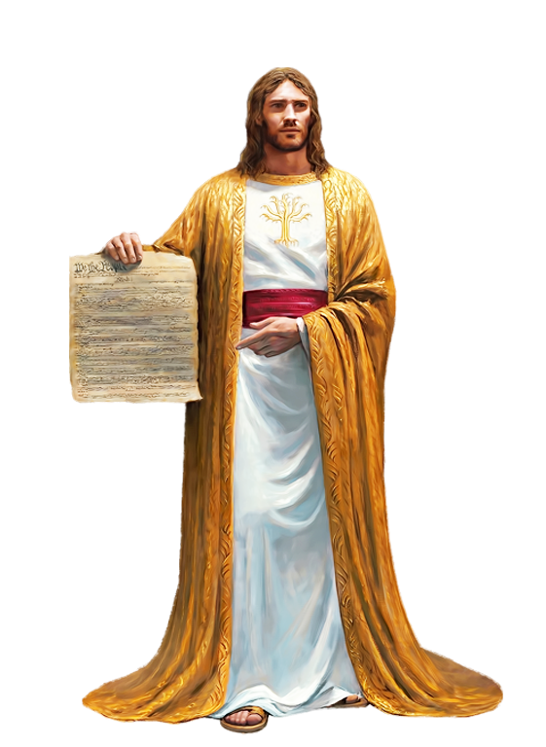
God is glorified when we bless and praise and acknowledge Him. That acknowledgement comes in the form of praise, adoration, thanksgiving and love. That is what we were originally created for. However, no man can bless God in this way unless He is right with God for we read in Proverbs 28:9: 'If anyone turns a deaf ear to the Law, even his prayers are detestable.' It is only once we have been truly blessed by God in the heavenly realms (Ephesians 1:3) that we can bless God in return, in a manner that pleases Him.
Pastor Tony
Church Information
Last Week’s giving: $ 210 Month to date: $ 2,689
Weekly Target: $ 875 Previous month: $ 3,139
Year to Date: $ 8,661 Monthly Target: $ 3,500
YTD target: $11,375 (-3,589) Building Fund: $ 10,580
Adult Sunday School 9:45 am………………………………….. Linda Fraley
Elders
Tony Raker (Pastor)..…………………........... tonyraker@yahoo.com
Delmas (Moe) Ritenour ……………………….. moemar@shentel.net
Finance: Anthony Sinecoff……………………….. sinecoff@gmail.com
Linda Fraley …………………………….. lindaf12@shentel.net

Media: Rob Moses, Scott Tucker, & Tammy Copeland
Bulletin: Rob Moses ……………. admin@graceevfreechurchva.org
Tammy Copeland …………..……..… …tammyscopeland@gmail.com
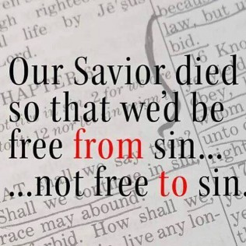
Grace Evangelical Free Church
718 E Queen Street, Strasburg, VA 22657, 540-465-4744 msg ph
https://graceevfreechurchva.org
Please put cell phones on vibrate!
Notes:

