Today’s Service
March 11, 2018
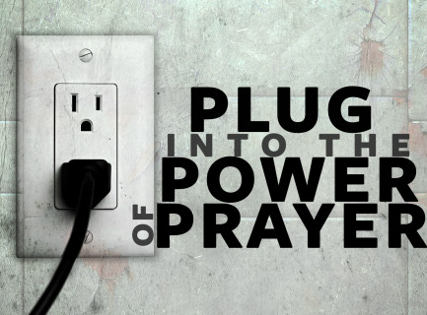
- Call to Worship
- Hymn
- Announcements
- Prayer Requests
- Music
- Sermon
- Offering

From the Pastor
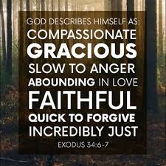
God being merciful basically means that, when we deserve punishment, He doesn’t punish us, and in fact blesses us instead. Mercy is coupled with other attributes of God in Psalm 86:15, “You, O Lord, are a God merciful and gracious, slow to anger and abounding in steadfast love and faithfulness.” He is merciful, in large part, because He is love (1 John 4:8). As sinners, we deserve punishment (Romans 3:23). God’s righteousness requires punishment for sin—He wouldn’t be holy otherwise. Since God does love us and is merciful, He sent His Son (John 3:16). Jesus is brutally beaten and murdered on our behalf; Jesus received our just condemnation, and we received God’s mercy.
Pastor Tony
Church Information
Last Week’s giving: $ 360 Month to date: $ 360
Weekly Target: $ 875 Previous month: $ 1,634
Year to Date: $ 3,463 Monthly Target: $ 3,500
YTD target: $7,875 (-4,412) Building Fund: $ 10,580
Adult Sunday School 9:45 am………………………………….. Linda Fraley
Elders
Tony Raker (Pastor)..…………………........... tonyraker@yahoo.com
Delmas (Moe) Ritenour ……………………….. moemar@shentel.net
Finance: Anthony Sinecoff……………………….. sinecoff@gmail.com
Linda Fraley …………………………….. lindaf12@shentel.net

Media: Rob Moses, Scott Tucker, & Tammy Copeland
Bulletin: Rob Moses ……………. admin@graceevfreechurchva.org
Tammy Copeland …………..……..… …tammyscopeland@gmail.com
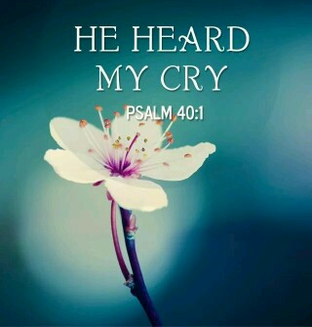

Grace Evangelical Free Church
718 E Queen Street, Strasburg, VA 22657, 540-465-4744 msg ph
https://graceevfreechurchva.org
Please put cell phones on vibrate!
Notes:

