Today’s Service
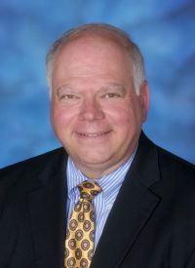
Feb 18, 2018
- Call to Worship
- Hymn
- Announcements
- Prayer Requests
- Music
- Sermon
- Offering
From the Pastor

Rebellion is opposition to authority. Rebellion can become violent but it can also remain unexpressed. Rebellion always begins in the heart. Rebellion against God’s authority was humanity’s first sin (Gen. 3) and continues to be our downfall. Our sinful natures do not want to bow to the authority of another, even God. We want to be our own bosses, and that rebellion in the human heart is the root of all sin (Romans 3:23).
The answer? Submission. Humble acknowledgment of our need of God and surrender to His will and way both for salvation and our daily walk. Pastor Tony

Church Information
Last Week’s giving: $ 584 Month to date: $ 1,364
Weekly Target: $ 875 Previous month: $ 1,469
Year to Date: $ 2,833 Monthly Target: $ 3,500
YTD target: $4375 (-2,417) Building Fund: $ 10,580
Adult Sunday School 9:45 am………………………………….. Linda Fraley
Elders
Tony Raker (Pastor)..…………………........... tonyraker@yahoo.com
Delmas (Moe) Ritenour ……………………….. moemar@shentel.net
Finance: Anthony Sinecoff……………………….. sinecoff@gmail.com
Linda Fraley …………………………….. lindaf12@shentel.net

Media: Rob Moses, Scott Tucker, & Tammy Copeland
Bulletin: Rob Moses ……………. admin@graceevfreechurchva.org
Tammy Copeland …………..……..… …tammyscopeland@gmail.com


Grace Evangelical Free Church
718 E Queen Street, Strasburg, VA 22657, 540-465-4744 msg ph
https://graceevfreechurchva.org
Please put cell phones on vibrate!
Notes:



