Today’s Service
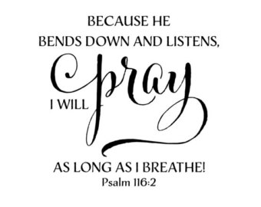
Dec 9, 2018
- Call to Worship
- Hymn
- Announcements
- Prayer Requests
- Music
- Sermon
- Offering
From the Pastor

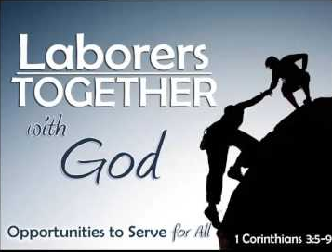
“For we are God's fellow workers. You are God's field, God's building” (1 Cor. 3:9). It gives a peculiar sacredness to the spiritual gifts given and subsequent work we, his laborers, perform on behalf of our Master. There is no higher honor than for a person to be engaged in doing the call of God, participating with Him in accomplishing His glorious plans. Indeed, while it is our reasonable service (Rom. 12:1) given Christ’s provision of salvation, restoration of our peace and underscoring our value as created in God’s image yet does He also entreat us to service which, faithfully executed, He also rewards us. Oh, what a Savior!
Pastor Tony
Church Information
Last Week’s giving: $ 1,900 Month to date: $ 1,900
Weekly Goal: $ 875 Previous month: $ 5,239
Weekly Average: & 811 Monthly Goal: $ 3,500
Elders
Tony Raker (Pastor)..……………………........... tonyraker@yahoo.com
Delmas (Moe) Ritenour ………………………….. moemar@shentel.net
Finance: Anthony Sinecoff………………………….. sinecoff@gmail.com
Linda Fraley ……………………………….. lindaf12@shentel.net

Media: Rob Moses, Scott Tucker, & Tammy Copeland
Bulletin: Rob Moses ………………. admin@graceevfreechurchva.org
Breakfast: Tammy Copeland ……….…tammyscopeland@gmail.com
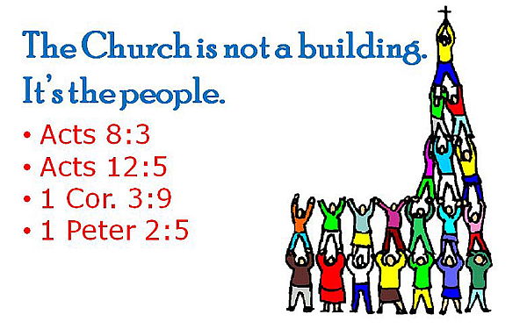
Adult Sunday School 9:45 am…………………………………….. Linda Fraley

Grace Evangelical Free Church
718 E Queen Street, Strasburg, VA 22657, 540-465-4744 msg ph
https://graceevfreechurchva.org
Please put cell phones on vibrate
Notes:
Next Breakfast is January 19th.

Lord, keep your arm around my shoulder & your hand over my mouth!
