Today’s Service

Nov 25, 2018
- Call to Worship
- Hymn
- Announcements
- Prayer Requests
- Music
- Sermon
- Offering
From the Pastor
Jesus is the only way to heaven. Such an exclusive statement may confuse, surprise, or even offend, but it is true nonetheless. The Bible teaches that there is no other way to salvation than through Jesus Christ (John 14:6). He is not a way, as in one of many; He is the way, as in the one and only (Eph. 4:5). No one, regardless of reputation, achievement, special knowledge, or personal holiness, can come to God the Father except through Jesus. Many followers turned their backs on Him, leaving in hopes of finding another savior. Jesus asked the Twelve, “Do you want to go away as well?” (John 6:67). Peter’s reply is exactly right: “Lord, to whom shall we go? You have the words of eternal life, and we have believed, and have come to know, that you are the Holy One of God” (John 6:68–69).
Pastor Tony
Church Information
Last Week’s giving: $ 280 Month to date: $ 3,724
Weekly Goal: $ 875 Previous month: $ 1,192
Weekly Average: & 790 Monthly Goal: $ 3,500
Elders
Tony Raker (Pastor)..……………………........... tonyraker@yahoo.com
Delmas (Moe) Ritenour ………………………….. moemar@shentel.net
Finance: Anthony Sinecoff………………………….. sinecoff@gmail.com
Linda Fraley ……………………………….. lindaf12@shentel.net

Media: Rob Moses, Scott Tucker, & Tammy Copeland
Bulletin: Rob Moses ………………. admin@graceevfreechurchva.org
Breakfast: Tammy Copeland ……….…tammyscopeland@gmail.com
Adult Sunday School 9:45 am…………………………………….. Linda Fraley
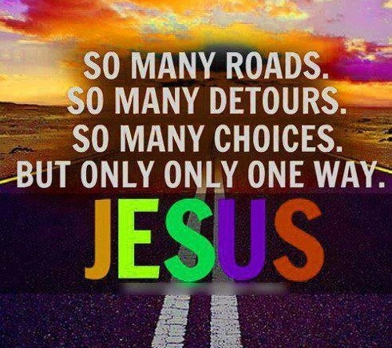
Grace Evangelical Free Church
718 E Queen Street, Strasburg, VA 22657, 540-465-4744 msg ph
https://graceevfreechurchva.org
Please put cell phones on vibrate

Notes:
.

Exercise daily. Run from Satan, walk with God
Christmas gift idea: bowtie for the Pastor!
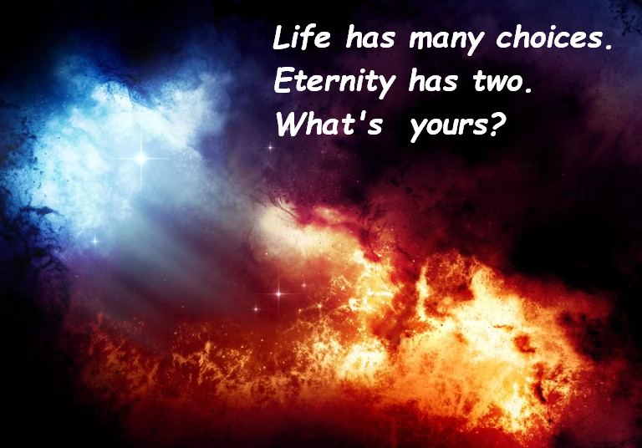
Next Breakfast is January 19th

