Today’s Service
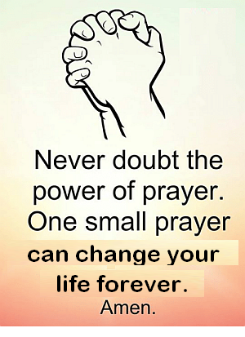
Nov 18, 2018
- Call to Worship
- Hymn
- Announcements
- Prayer Requests
- Music
- Sermon
- Offering
From the Pastor
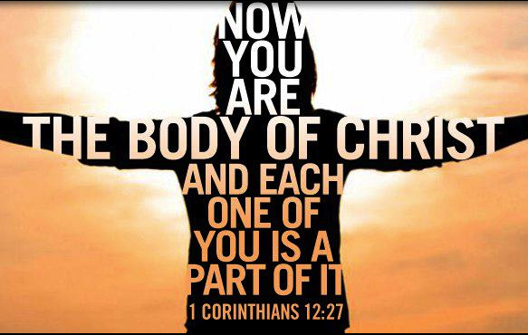
The universal Church—the Body of Christ (Romans 12:5)—is composed of all true believers in Christ, and local churches are to be microcosm of the universal Church. As believers, we have our names written in the Lamb’s book of life (Revelation 20:12), and that is what is most important. However, it is also important to commit to a local church where we can give of our resources, serve others, exercise our spiritual gifts and be accountable. Church membership is a way of identifying oneself with a local body of believers and of making oneself accountable to proper spiritual leadership. Church membership is a statement of solidarity and like-mindedness (see Philippians 2:2).
Pastor Tony

Church Information
Last Week’s giving: $ 2,030 Month to date: $ 3,444
Weekly Goal: $ 875 Previous month: $ 1,192
Weekly Average: & 783 Monthly Goal: $ 3,500
Elders
Tony Raker (Pastor)..……………………........... tonyraker@yahoo.com
Delmas (Moe) Ritenour ………………………….. moemar@shentel.net
Finance: Anthony Sinecoff………………………….. sinecoff@gmail.com
Linda Fraley ……………………………….. lindaf12@shentel.net

Media: Rob Moses, Scott Tucker, & Tammy Copeland
Bulletin: Rob Moses ………………. admin@graceevfreechurchva.org
Breakfast: Tammy Copeland ……….…tammyscopeland@gmail.com
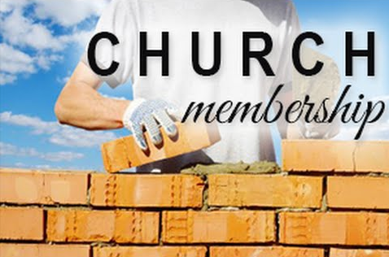
Adult Sunday School 9:45 am…………………………………….. Linda Fraley

Grace Evangelical Free Church
718 E Queen Street, Strasburg, VA 22657, 540-465-4744 msg ph
https://graceevfreechurchva.org
Please put cell phones on vibrate
Notes:
.

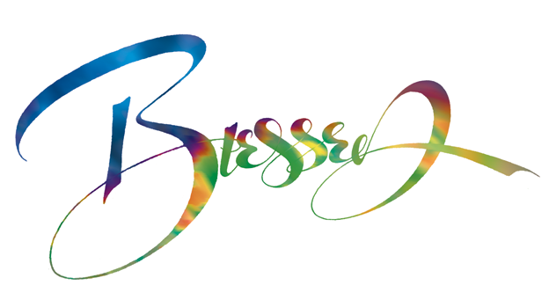
Next Breakfast is January 19th
