Today’s Service
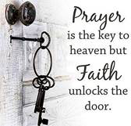
Oct 21, 2018
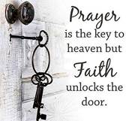
- Call to Worship
- Hymn
- Announcements
- Prayer Requests
- Music
- Sermon
- Offering

From the Pastor
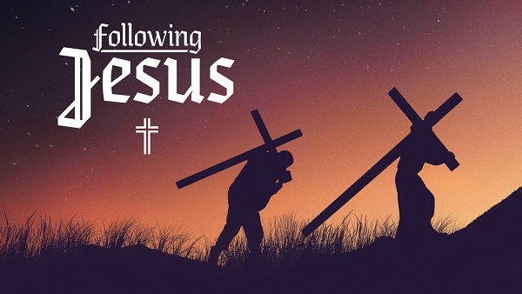
Jesus talked to those who would follow Him about taking up a cross, counting the cost, and giving up everything (Luke 14:25—33). “The way is hard that leads to life,” He said (Mt. 7:14). Jesus did not come to reform our flesh, but to crucify it (Rom. 6:6–7). But the flesh does not want to die. When we cling to our rights, our opinions, and our agenda, we remain the lords of our own lives. When we lay our will on the altar before God and let go, we die to ourselves. We can then be “filled with the Holy Spirit,” totally controlled by Him (Acts 4:8; 13:52; Eph. 5:18). It is only through the power of the Holy Spirit that we can live a life that honors God. Living for God may be difficult, but it is not joyless. Paul wrote his most joyful letter while suffering persecution in Rome (Philippians). We will still face temptation and hardship, but when the glory of God is our focus, living for Him becomes the source of our joy rather (Ps. 100:2; 1 Cor. 6:20; 1 Peter 4:16).
Pastor Tony
Church Information
Last Week’s giving: $ 905 Month to date: $ 1,062
Previous month: $ 6,395 Monthly Average: $ 773
Elders
Tony Raker (Pastor)..……………………........... tonyraker@yahoo.com
Delmas (Moe) Ritenour ………………………….. moemar@shentel.net
Finance: Anthony Sinecoff………………………….. sinecoff@gmail.com
Linda Fraley ……………………………….. lindaf12@shentel.net

Media: Rob Moses, Scott Tucker, & Tammy Copeland
Bulletin: Rob Moses ………………. admin@graceevfreechurchva.org
Breakfast: Tammy Copeland ……….…tammyscopeland@gmail.com
Adult Sunday School 9:45 am…………………………………….. Linda Fraley
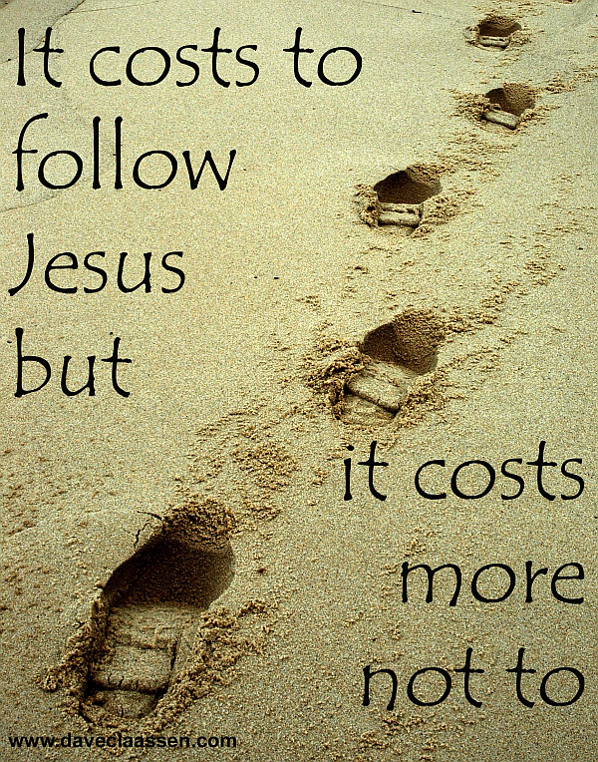
Grace Evangelical Free Church
718 E Queen Street, Strasburg, VA 22657, 540-465-4744 msg ph
https://graceevfreechurchva.org
Please put cell phones on vibrate!
Notes:

.

