Today’s Service
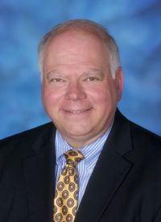
Jan 28, 2018
- Call to Worship
- Hymn
- Announcements
- Prayer Requests
- Music
- Sermon
- Offering
From the Pastor

Novelty is no substitute for clarity. Jesus’ half-brother Jude challenges the church in its infancy…and in our modern context to not just avoid, but call out and kick out those who have infiltrated local fellowships spreading any other truth then Christ and Him crucified. No special word of knowledge. No meritorious works – including baptism. No spiritually privileged ‘in’ group. No, the task of preacher and layman alike is be a witness to the saving grace of Jesus Christ thereby avoiding confusion, dissention and loss of testimony and influence a dying world so desperately requires.
Pastor Tony
Church Information
Last Week’s giving: $ 60 Month to date: $ 1,105
Weekly Target: $ 875 Previous month: $ 4,097
Year to Date: $ 1,105 Monthly Target: $ 3,500
YTD target: $2,625 (-1,520) Building Fund: $ 10,580
Adult Sunday School 9:45 am………………………………….. Linda Fraley
Elders
Tony Raker (Pastor)..…………………........... tonyraker@yahoo.com
Delmas (Moe) Ritenour ……………………….. moemar@shentel.net
Finance: Anthony Sinecoff……………………….. sinecoff@gmail.com
Linda Fraley …………………………….. lindaf12@shentel.net

Media: Rob Moses, Scott Tucker, & Tammy Copeland
Bulletin: Rob Moses ……………. admin@graceevfreechurchva.org
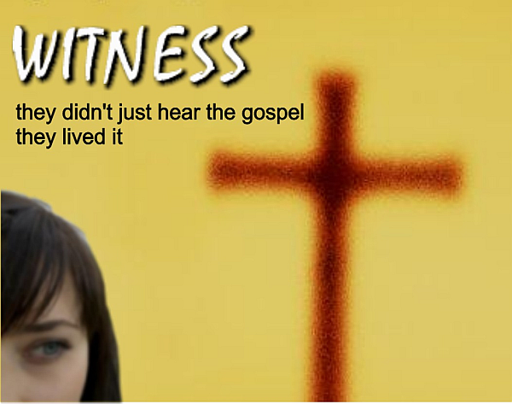
Tammy Copeland …………..……..… …tammyscopeland@gmail.com

Grace Evangelical Free Church
718 E Queen Street, Strasburg, VA 22657, 540-465-4744 msg ph
https://graceevfreechurchva.org
Please put cell phones on vibrate!
Notes:
Communion next week!

