Today’s Service
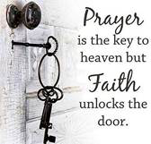
Sept 30, 2018
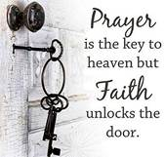
- Call to Worship
- Hymn
- Announcements
- Prayer Requests
- Music
- Sermon
- Offering


From the Pastor
In Ephesians 3, Paul talks about our spiritual strength or enablement. As Christians, we are to be strong in the mighty power of God. This means that our strength is not our own; it is not human or fleshly – that’s a relief! No, our strength is not of the world, but our strength is found in Christ—in our having a vibrant, dynamic relationship with Him and the Holy Spirit. That relationship is one of submission which is perhaps the hardest thing for us. Face it: we have trouble obeying the speed limit much less God. Yet, it is through submission to God’s strength that we overcome the power of Satan, aligning ourselves with the strength of God through our total submission to Him that we are able to withstand the wiles of the evil one.
Pastor Tony
Church Information
Last Week’s giving: $ 740 Month to date: $ 2,800
Previous month: $ 2,183 Monthly Average: $ 3,624
Elders
Tony Raker (Pastor)..……………………........... tonyraker@yahoo.com
Delmas (Moe) Ritenour ………………………….. moemar@shentel.net
Finance: Anthony Sinecoff………………………….. sinecoff@gmail.com
Linda Fraley ……………………………….. lindaf12@shentel.net

Media: Rob Moses, Scott Tucker, & Tammy Copeland
Bulletin: Rob Moses ………………. admin@graceevfreechurchva.org
Breakfast: Tammy Copeland ……….…tammyscopeland@gmail.com
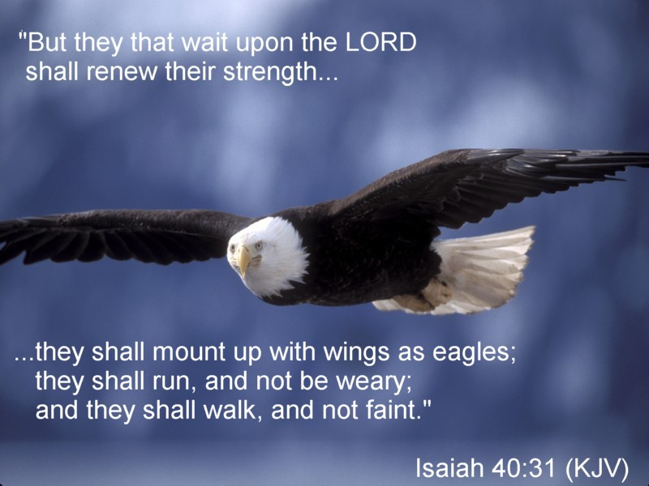
Adult Sunday School 9:45 am…………………………………….. Linda Fraley

Grace Evangelical Free Church
718 E Queen Street, Strasburg, VA 22657, 540-465-4744 msg ph
https://graceevfreechurchva.org
Please put cell phones on vibrate!
Notes:
Pray today for those on the Prayer List

