Today’s Service
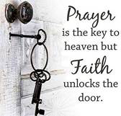
Sept 16, 2018
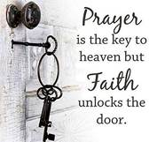
- Call to Worship
- Hymn
- Announcements
- Prayer Requests
- Music
- Sermon
- Offering

From the Pastor
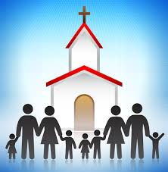
Many people today understand the church as a building. This is not a biblical understanding of the church. The word "church" comes from the Greek word ‘ekklesia’ which is defined as "an assembly" or "called-out ones." According to the Bible, the church is the body of Christ—all those who have placed their faith in Jesus Christ for salvation (Jn. 3:16; 1 Cor. 12:13). Local churches are gatherings of people who claim the name of Christ. Members of a local church may or may not be members of the universal church, depending on the genuineness of their faith. The local church is where believers can fully apply the “body” convictions of 1 Cor. 12: encouraging, teaching, and building one another up in the knowledge and grace of the Lord Jesus Christ.
Pastor Tony
Church Information
Last Week’s giving: $ 180 Month to date: $ 1,210
Previous month: $ 2,183 Monthly Average: $ 3,507
Elders
Tony Raker (Pastor)..……………………........... tonyraker@yahoo.com
Delmas (Moe) Ritenour ………………………….. moemar@shentel.net
Finance: Anthony Sinecoff………………………….. sinecoff@gmail.com
Linda Fraley ……………………………….. lindaf12@shentel.net

Media: Rob Moses, Scott Tucker, & Tammy Copeland
Bulletin: Rob Moses ………………. admin@graceevfreechurchva.org
Breakfast: Tammy Copeland ……….…tammyscopeland@gmail.com
Adult Sunday School 9:45 am…………………………………….. Linda Fraley
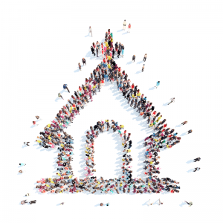
Grace Evangelical Free Church
718 E Queen Street, Strasburg, VA 22657, 540-465-4744 msg ph
https://graceevfreechurchva.org
Please put cell phones on vibrate!
Notes:
Pray today for those on the Prayer List

