Today’s Service
Sept 9, 2018
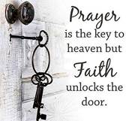
- Call to Worship
- Hymn
- Announcements
- Prayer Requests
- Music
- Sermon
- Offering

From the Pastor
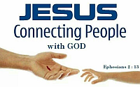
Ephesians 2:13 says, “In Christ Jesus you who once were far away have been brought near by the blood of Christ.” God took us, poor orphans in this world, and made us a part of His family through faith in Jesus Christ. He has showered us with blessings and promised us an eternal inheritance, based on the worthiness of Christ Himself. Being a co-heir with Christ means that we, as God’s adopted children, will share in the inheritance of Jesus: His glory (John 17:22), His riches (2 Cor. 8:9), and all things (Heb. 1:2). We are as welcome in God’s family as Jesus is; we are “blessed in the Beloved.” (Eph. 1:6).
Pastor Tony
Church Information
Last Week’s giving: $ 1,030 Month to date: $ 1,030
Previous month: $ 2,183 Monthly Average: $ 3,340
Elders
Tony Raker (Pastor)..……………………........... tonyraker@yahoo.com
Delmas (Moe) Ritenour ………………………….. moemar@shentel.net
Finance: Anthony Sinecoff………………………….. sinecoff@gmail.com
Linda Fraley ……………………………….. lindaf12@shentel.net

Media: Rob Moses, Scott Tucker, & Tammy Copeland
Bulletin: Rob Moses ………………. admin@graceevfreechurchva.org
Breakfast: Tammy Copeland ……….…tammyscopeland@gmail.com
Adult Sunday School 9:45 am…………………………………….. Linda Fraley
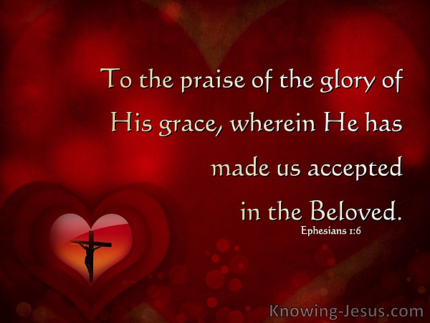
Grace Evangelical Free Church
718 E Queen Street, Strasburg, VA 22657, 540-465-4744 msg ph
https://graceevfreechurchva.org
Please put cell phones on vibrate!
Notes:
Pray today for those on the Prayer List

