Today’s Service
Aug 26, 2018

- Call to Worship
- Hymn
- Announcements
- Prayer Requests
- Music
- Sermon
- Offering
- Communion
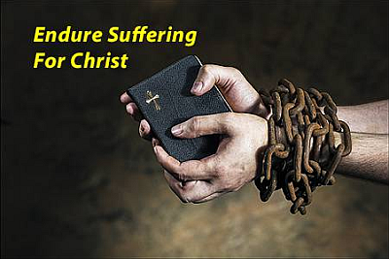
From the Pastor
Of all the challenges thrown at Christianity in modern times, perhaps the most difficult is explaining the problem of suffering. When asked how much God cares about the problem of evil and suffering, the Christian God can point to the cross and say, “That much.” Christ experienced physical pain as well as feelings of rejection and abandonment. He experienced the same suffering as many people today who know the bitterness of isolation, pain, and anguish. In His providence, God orchestrates every event in our lives—even suffering—to accomplish both our temporal and eternal benefit (Romans 8:28).
Pastor Tony

Church Information
Last Week’s giving: $ 730 Weekly Average: $ 731
Weekly Target: $ 800 Month to date: $ 2,091
Year to Date: $ 24,133 Previous month: $ 3,551
YTD compared to goal: (-4,792) Monthly Target: $ 3,500
YTD Target: $ 28,875 Monthly Average: $ 3,328
Adult Sunday School 9:45 am…………………………………….. Linda Fraley
Elders
Tony Raker (Pastor)..……………………........... tonyraker@yahoo.com
Delmas (Moe) Ritenour ………………………….. moemar@shentel.net
Finance: Anthony Sinecoff………………………….. sinecoff@gmail.com
Linda Fraley ……………………………….. lindaf12@shentel.net

Media: Rob Moses, Scott Tucker, & Tammy Copeland
Bulletin: Rob Moses ………………. admin@graceevfreechurchva.org

Breakfast: Tammy Copeland ……….…tammyscopeland@gmail.com

Grace Evangelical Free Church
718 E Queen Street, Strasburg, VA 22657, 540-465-4744 msg ph
https://graceevfreechurchva.org
Please put cell phones on vibrate!
Notes:
Pray today for those on the Prayer List



