Today’s Service
Aug 19, 2018
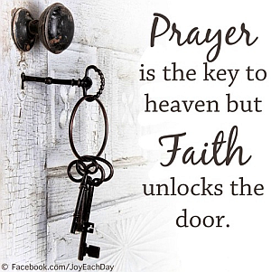
- Call to Worship
- Hymn
- Announcements
- Prayer Requests
- Music
- Sermon
- Offering

From the Pastor

Unity is one of the most important themes in the New Testament. In Jesus’ longest recorded prayer, He prayed that His followers would “be one as you and I, Father, are one” (John 17:21). The apostle Paul pleaded with the churches in many of his epistles to “preserve the unity of the Spirit through the bond of peace” (Ephesians 4:3). Colossians 3:12–14 says, “Therefore, as God’s chosen people, holy and dearly loved, clothe yourselves with compassion, kindness, humility, gentleness, and patience. Bear with each other and forgive one another if any of you has a grievance against someone. Forgive as the Lord forgave you. And over all these virtues put on love, which binds them all together in perfect unity.” Always remember: “How good and pleasant it is when God’s people live together in unity!” (Psalm 133:1).
Pastor Tony

Church Information
Last Week’s giving: $ 110 Weekly Average: $ 731
Weekly Target: $ 800 Month to date: $ 1,369
Year to Date: $ 23,403 Previous month: $ 3,551
YTD compared to goal: (-4,579) Monthly Target: $ 3,500
YTD Target: $ 28,000 Monthly Average: $ 3,228
Adult Sunday School 9:45 am…………………………………….. Linda Fraley
Elders
Tony Raker (Pastor)..……………………........... tonyraker@yahoo.com
Delmas (Moe) Ritenour ………………………….. moemar@shentel.net
Finance: Anthony Sinecoff………………………….. sinecoff@gmail.com
Linda Fraley ……………………………….. lindaf12@shentel.net

Media: Rob Moses, Scott Tucker, & Tammy Copeland
Bulletin: Rob Moses ………………. admin@graceevfreechurchva.org
Breakfast: Tammy Copeland ……….…tammyscopeland@gmail.com
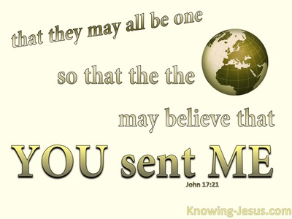

Grace Evangelical Free Church
718 E Queen Street, Strasburg, VA 22657, 540-465-4744 msg ph
https://graceevfreechurchva.org
Please put cell phones on vibrate!
Notes:

