Today’s Service
Aug 12, 2018
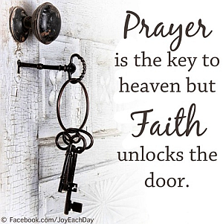
- Call to Worship
- Hymn
- Announcements
- Prayer Requests
- Music
- Sermon
- Offering

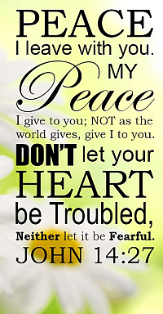
From the Pastor
Jesus assures of peace unlike any other (John 14:27). His peace meets all the wants of the soul, silences the alarms of conscience, is fixed and sure amid all external changes and will abide in the hour of death and forever thereafter. How desirable, in a world of anxiety and care, to possess this peace! And how should all who don’t have it, seek that which the world can neither give nor take away! Jesus prefaced this gift with the reality of His existence and essence of love and care (John 14:1-2). In the midst of pain, persecutions, or trials of every kind, be not dumfounded as the world as you have a Friend who will never leave you; a peace that shall always sustain you.
Pastor Tony
Church Information
Last Week’s giving: $ 1,259 Weekly Average: $ 751
Weekly Target: $ 800 Month to date: $ 1,259
Year to Date: $ 23,293 Previous month: $ 3,551
YTD compared to goal: (-3,832) Monthly Target: $ 3,500
YTD Target: $ 27,125 Monthly Average: $ 3,212
Adult Sunday School 9:45 am…………………………………….. Linda Fraley
Elders
Tony Raker (Pastor)..……………………........... tonyraker@yahoo.com
Delmas (Moe) Ritenour ………………………….. moemar@shentel.net
Finance: Anthony Sinecoff………………………….. sinecoff@gmail.com
Linda Fraley ……………………………….. lindaf12@shentel.net

Media: Rob Moses, Scott Tucker, & Tammy Copeland
Bulletin: Rob Moses ………………. admin@graceevfreechurchva.org
Breakfast: Tammy Copeland ……….…tammyscopeland@gmail.com
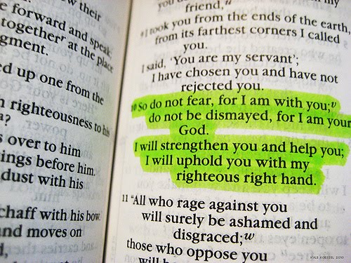

Grace Evangelical Free Church
718 E Queen Street, Strasburg, VA 22657, 540-465-4744 msg ph
https://graceevfreechurchva.org
Please put cell phones on vibrate!
Notes:

