Today’s Service
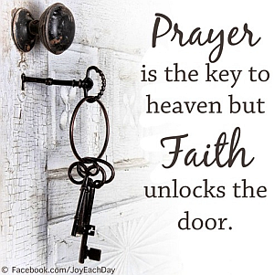
July 22, 2018
- Call to Worship
- Hymn
- Announcements
- Prayer Requests
- Music
- Sermon
- Offering

From the Pastor
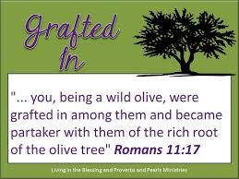
In Romans 11:11–24 Paul compares Israel to the natural branches of a cultivated olive tree and the Gentile believers to the branches of a wild olive tree. The natural branches (Israel) were broken off, and the wild branches (Gentiles) were grafted in (v 17). The Gentiles, then, have been made partakers of the promises and inherit the blessings of God’s salvation. This is the impetus for Paul’s instruction to the Ephesians where he emphasizes we are all one in Christ, the tie that binds – ignoring race, sex, socio-economic status and nationality. Under whom else could we all be one?
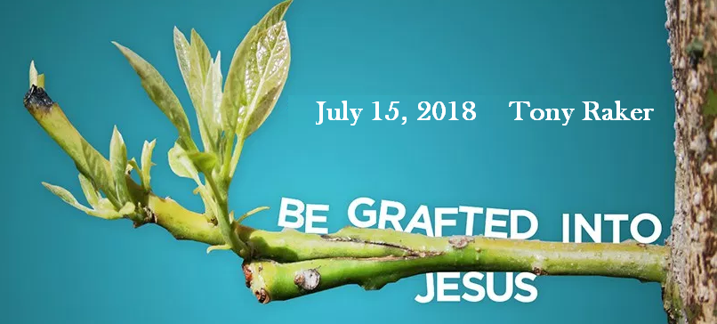
Pastor Tony

Church Information
Last Week’s giving: $ 1,454 Month to date: $ 2,232
Weekly Target: $ 800 Previous month: $ 2,754
Year to Date: $ 20,715 Monthly Target: $ 3,500
YTD: (-3,785) YTD Target: $ 24,500
Adult Sunday School 9:45 am…………………………………….. Linda Fraley
Elders
Tony Raker (Pastor)..……………………........... tonyraker@yahoo.com
Delmas (Moe) Ritenour ………………………….. moemar@shentel.net
Finance: Anthony Sinecoff………………………….. sinecoff@gmail.com
Linda Fraley ……………………………….. lindaf12@shentel.net

Media: Rob Moses, Scott Tucker, & Tammy Copeland
Bulletin: Rob Moses ………………. admin@graceevfreechurchva.org
Breakfast: Tammy Copeland ……….…tammyscopeland@gmail.com
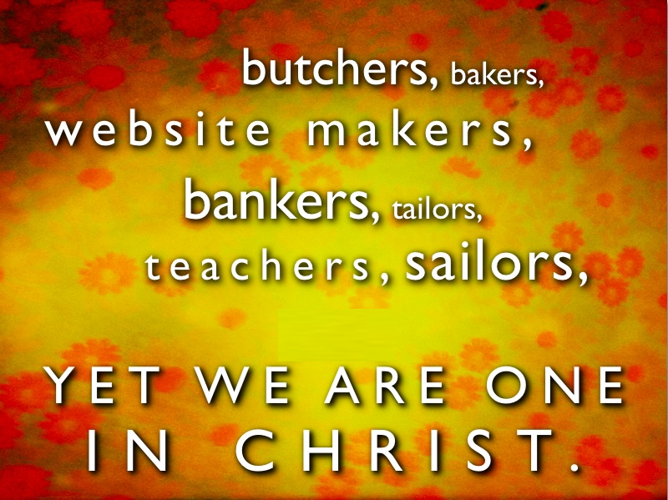

Grace Evangelical Free Church
718 E Queen Street, Strasburg, VA 22657, 540-465-4744 msg ph
https://graceevfreechurchva.org
Please put cell phones on vibrate!
Notes:
Happy Anniversary Art & Betty Cheny!

