Today’s Service
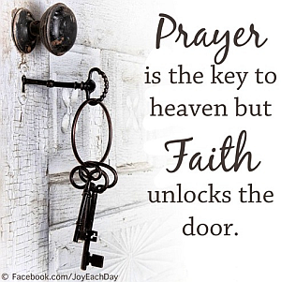
July 8, 2018
- Call to Worship
- Hymn
- Announcements
- Prayer Requests
- Music
- Sermon
- Communion
- Offering

From the Pastor
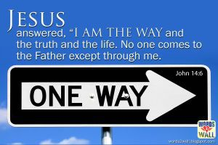
Jesus is the only way to heaven. Such an exclusive statement may grate on the postmodern ear, but it is true nonetheless. The Bible teaches that there is no other way to salvation than through Jesus Christ. Jesus Himself says in John 14:6, “I am the way, the truth, and the life. No one comes to the Father except through me.” He is not a way, as in one of many; He is the way, as in the one and only. No one, regardless of reputation, achievement, special knowledge, or personal holiness, can come to God the Father except through Jesus. We must trust in Jesus’ death on the cross as our payment for sin and in His resurrection because “This righteousness from God comes through faith in Jesus Christ to all who believe” (Romans 3:22).
Pastor Tony

Church Information
Last Week’s giving: $ 504 Month to date: $ 504
Weekly Target: $ 800 Previous month: $ 2,754
Year to Date: $ 18,983 Monthly Target: $ 3,500
YTD target: $18,987 (-3,763) YTD Target: $ 22,750
Adult Sunday School 9:45 am………………………………….. Linda Fraley
Elders
Tony Raker (Pastor)..…………………........... tonyraker@yahoo.com
Delmas (Moe) Ritenour ……………………….. moemar@shentel.net
Finance: Anthony Sinecoff……………………….. sinecoff@gmail.com
Linda Fraley …………………………….. lindaf12@shentel.net

Media: Rob Moses, Scott Tucker, & Tammy Copeland
Bulletin: Rob Moses ……………. admin@graceevfreechurchva.org
Breakfast: Tammy Copeland …….…tammyscopeland@gmail.com
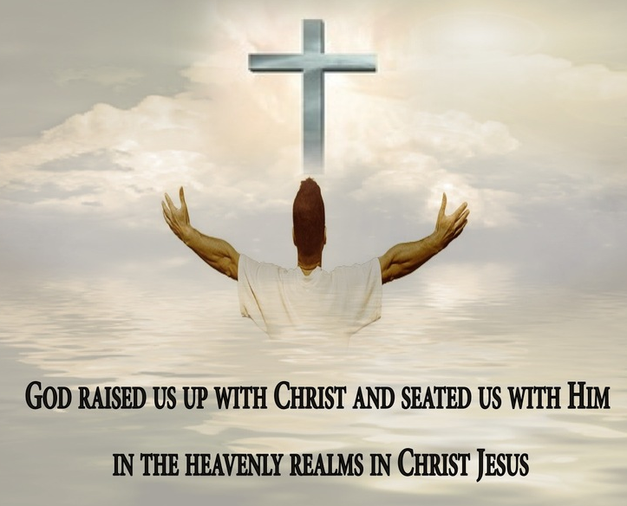

Grace Evangelical Free Church
718 E Queen Street, Strasburg, VA 22657, 540-465-4744 msg ph
https://graceevfreechurchva.org
Please put cell phones on vibrate!
Notes:
Travel mercies for Pastor Tony and Caroline!



