Today’s Service
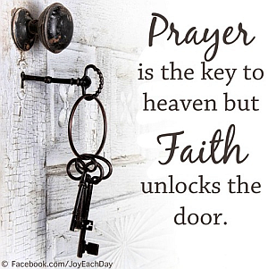
July 1, 2018
- Call to Worship
- Hymn
- Announcements
- Prayer Requests
- Music
- Sermon
- Offering

Communion next week!
From the Pastor

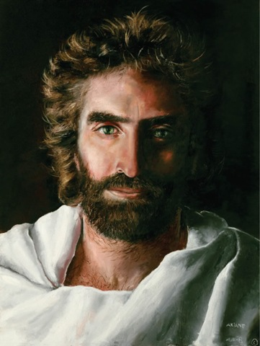
Sometimes we look at the Old Testament and think that God only loves people as a nation, not as individuals. But it is important to remember that Ruth, Hagar, David, Abraham, Moses and Jeremiah were all individuals. God stepped into each of their lives and loved them individually. This love becomes obvious in the person of Jesus: God confining Himself to human skin in order to redeem us (Phil. 2:5-11). He entered our world as a baby born to an unassuming family in a very humble way. Jesus grew up like any child would. During His public ministry, He often associated with society’s outcasts. He stopped for the sick. He healed. He listened to people. He blessed the children. And in so doing, He also taught us about God’s love for you and me.
Pastor Tony
Church Information
Last Week’s giving: $ 700 Month to date: $ 2,754
Weekly Target: $ 800 Previous month: $ 2,599
Year to Date: $ 18,483 Monthly Target: $ 3,500
YTD target: $21,875 (-3,292) Building Fund: $ 10,580
Adult Sunday School 9:45 am………………………………….. Linda Fraley
Elders
Tony Raker (Pastor)..…………………........... tonyraker@yahoo.com
Delmas (Moe) Ritenour ……………………….. moemar@shentel.net
Finance: Anthony Sinecoff……………………….. sinecoff@gmail.com
Linda Fraley …………………………….. lindaf12@shentel.net

Media: Rob Moses, Scott Tucker, & Tammy Copeland
Bulletin: Rob Moses ……………. admin@graceevfreechurchva.org
Breakfast: Tammy Copeland …….…tammyscopeland@gmail.com
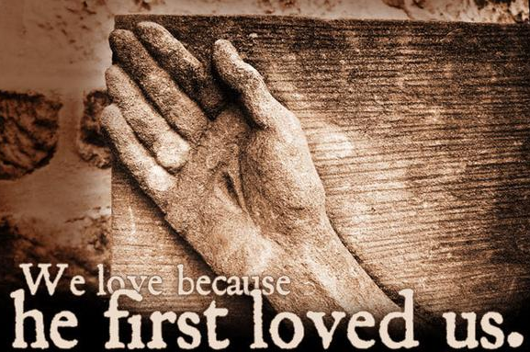

Grace Evangelical Free Church
718 E Queen Street, Strasburg, VA 22657, 540-465-4744 msg ph
https://graceevfreechurchva.org
Please put cell phones on vibrate!
Notes:
Travel mercies for Pastor Tony and Caroline!

